Project Phase II: Implementation Specification

*Versions 2.0*

CS/SE 6362 Advanced Software Architecture (Fall 2015)

**Submitted to:**

**Dr. Lawrence Chung,**

**Associate Professor,**

**Department of Computer Science,**

**The University of Texas at Dallas,**

**Richardson, TX -75080**

**Submitted By:** Team Name: Quick Search

**Sruthi Chappidi,** [**sxc105920@utdallas.edu**](mailto:sxc105920@utdallas.edu)**,**

**Barbara Maweu,** [**bmk101020@utdallas.edu**](mailto:bmk101020@utdallas.edu)

**Maryellen Oltman,** [**mco130030@utdallas.edu**](mailto:mco130030@utdallas.edu)

**Twinkle Sharma,**[**txs151730@utdallas.edu**](mailto:txs151730@utdallas.edu)**.**

**Team Website:** [**www.utdallas.edu/~maryellen.oltman**](http://www.utdallas.edu/~maryellen.oltman)

## Revision History

|  |  |  |  |
| --- | --- | --- | --- |
| Date | Version | Description | Author(s) |
| 11/10/2015 | 1.0 | Interim version of Cyberminer System Prototype | All |
| 12/1/2015 | 2.0 | Update output screen of implementation | All |

1. Class Description

There are 9 classes namely- MasterControl, RequestHandler, KWICData, LineStorage, CircularShift, Noise Eliminator, SearchModule, Alphabetizer, DataAccessModule

* MasterControl handles the sequence between 5 other modules. It delegates the request to RequestHandler sub-module. It also handles the request received from Front Controller and sequences the processing of data by deciding which module to instantiate.
* RequestHandler which passes on the input to other modules and handles requests.
* KWICData module is responsible for setting and getting the KWICData for modules like LineStorage, CircularShift, Alphabetizer and NoiseEliminator.
* Line Storage creates, accesses and possibly deletes characters, words or lines.
* CircularShift creates (virtual) lines of the circular shifts of the stored lines.
* Alphabetizer creates alphabetized lines of the circular shift lines.
* NoiseEliminator removes words like A, an, the, of, for, and etc.
* SearchModule helps in the main functionality of searching the database for the string that the user has requested for.
* DataAccessModule returns the data requested by the search module.

1. Prototype/ Screenshots

2.1 Prototype 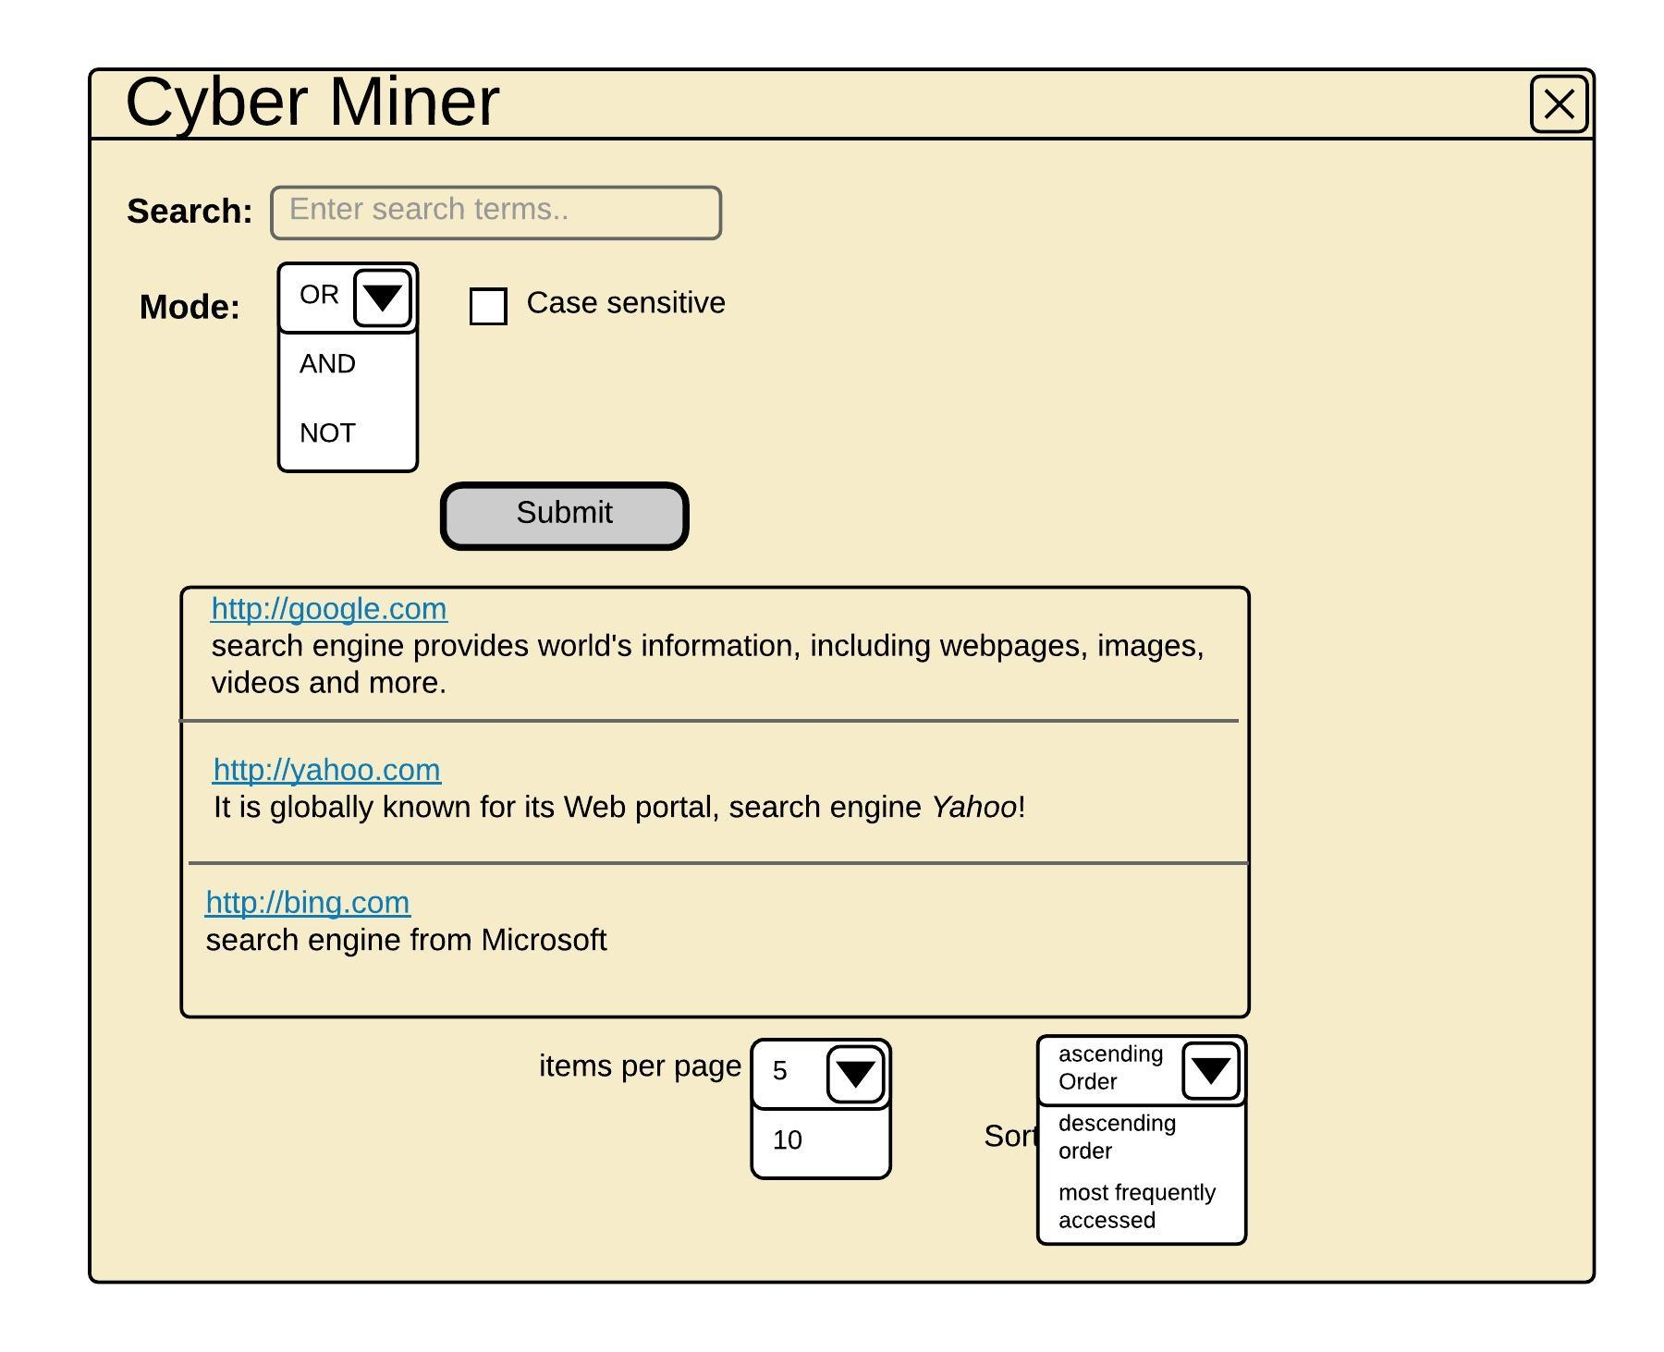

2.2 Implementation - KWIC indexing

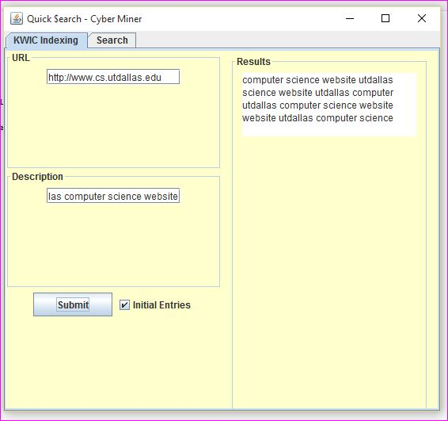

2.2 Implementation- CyberMiner

